CIS263AA Programming Assignment 15

Assignment Goal:

In this chapter you learned about Applets. Applet are Java programs that are invoked from a Web page.

Assignment Specifications:

Create an applet form called SalesCommissions that calculates commissions for 5 sales persons. Include as input the following data:

Salesperson name

Salesperson’s sales

Provide a variable for the total sales. Provide a variable for the percent of the salesperson’s sales to the total. Provide a variable for the commission. Provide variables to store the amount of each salesperson’s commission.

Commission rates are as follows:

0 – 250000 = 5%

250001 – 500000 = 7%

500001 – 750000 = 9%

750001 an up = 12%

Include a button that will cause the calculations to take place.

Extra Credit (20 points): Create a graph (either bar or line) that shows each salesperson’s commission in relationship to the other salespeople.

Deliverables (what you are to submit):

1. Planning document for SalesCommissions.
   1. Program Outline
   2. Methods
   3. Data Items
   4. Sample Output
   5. Test Data
2. Your completed project folder in zip format.

CIS263AA Programming Assignment 13 (SalesCommissions)

Name: ____Daniel Cender___________________________

**Program Outline:** < This is an outline of what your program is to do. Be detailed. >

Take in a salesperson’s name and total sales.

Calculate each salespersons’ commission

Calculate each commission in relation to other commissions.

Output the text results to the applet frame.

**Methods:** < This is a list of methods you will define in your program. >

|  |  |  |  |  |
| --- | --- | --- | --- | --- |
| **Function** | **Access Modifier(1)** | **Method Name** | **Parameters (dataType identifier)** | **Return Type (2)** |
| Main method: | public static | main() |  | void |
| Calculate Commission | public | calculateCommission() | (float sales) | float |
| Calculate Sales Percentage | public | calculateSalesPercentage() | (float c1, float c2, float c3, float c4, float c5) | void |

1. Access Modifier: local, public, private, protected

2. Return Type: void, string, char, byte, short, integer, long, double, float, boolean, object, etc.

**Data Items:** < This is a list of fields (variables, constants, and objects you will need. >

|  |  |  |  |  |  |
| --- | --- | --- | --- | --- | --- |
| **Data Item** | **Source (1)** | **Access Modifier (2)** | **Data Type (3)** | **Identifier** | **Notes** |
| Title Label | Instance | local | JLabel | titleLabel |  |
| Name Label | Instance | local | JLabel | nameLabel |  |
| Sales Label | Instance | local | JLabel | salesLabel |  |
| Person 1 Label | Instance | local | JLabel | person1Label |  |
| Person 1 Name Text | instance | local | JTextField | person1NameField |  |
| Person 1 Sales L | instance | local | JTextField | person1SalesField |  |
| Person 2 Label | instance | local | JLabel | person2Label |  |
| Person 2 Name Field | instance | local | JTextField | person2NameField |  |
| Person 2 Sales Field | instance | local | JTextField | person2SalesField |  |
| Person 3 Label | instance | local | JLabel | person3Label |  |
| Person 3 Name Field | instance | local | JTextField | person3NameField |  |
| Person 3 Sales Field | instance | local | JTextField | person3SalesField |  |
| Person 4 Label | instance | local | JLabel | person4Label |  |
| Person 4 Name Field | instance | local | JTextField | person4NameField |  |
| Person 4 Sales Field | instance | local | JTextField | person4SalesField |  |
| Person 5 Label | instance | local | JLabel | person5Label |  |
| Person 5 Name Field | instance | local | JTextField | person5NameField |  |
| Person 5 Sales Field | instance | local | JTextField | person5SalesField |  |
| Results Label | instance | local | JLabel | resultsLabel |  |
| Commission Label | instance | local | JLabel | commissionLabel |  |
| Commission Percent Label | instance | local | JLabel | commissionPercentLabel |  |
| Person 1 Commission Label | calculated | local | JLabel | person1CommissionLabel |  |
| Person 2 Commission label | calculated | local | JLabel | person2CommissionLabel |  |
| Person 3 Commission Label | calculated | local | JLabel | person3CommissionLabel |  |
| Person 4 Commission Label | calculated | local | JLabel | person4CommissionLabel |  |
| Person 5 Commission Label | calculated | local | JLabel | person5CommissionLabel |  |
| Person 1 Commission Percent Label | calculated | local | JLabel | person1CommissionPercentLabel |  |
| Person 2 Commission Percent Label | calculated | local | JLabel | person2CommissionPercentLabel |  |
| Person 3 Commission Percent Label | calculated | local | JLabel | person3CommissionPercentLabel |  |
| Person 4 Commission Percent Label | calculated | local | JLabel | person4CommissionPercentLabel |  |
| Person 5 Commission Percent Label | calculated | local | JLabel | person5CommissionPercentLabel |  |

1. Source (where the data comes from): calculated, input, constant, parameter, instance, object

2. Access Modifier: local, public, private, protected

3. Data Type: string, char, byte, short, integer, long, double, float, boolean, object, etc.

**Sample Output:** < What will the user see? >

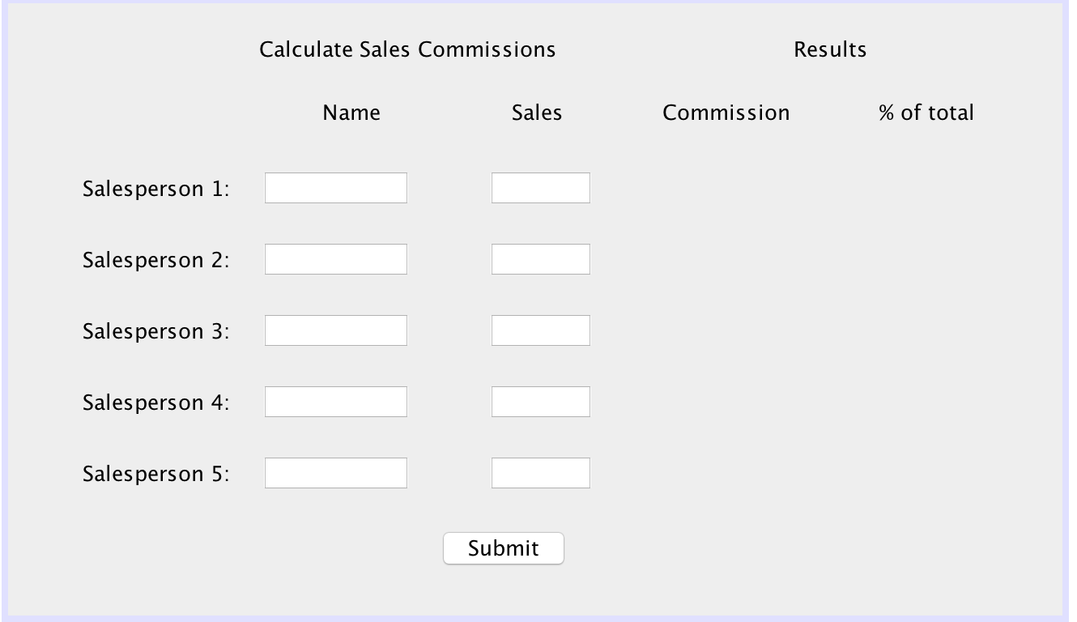

**Test Data:** < How will you prove your program works? >

|  |  |  |  |  |
| --- | --- | --- | --- | --- |
| **Identifier** | Case 1 | Case 2 | Case 3 | Case 4 |
| person1SalesField | 450,000 | 600,000 | 2,500,500 |  |
| person2SalesField | 30,000 | 700,000 | 5,600,000 |  |
| person3SalesField | 56,000 | 900,000 | 230,000 |  |
| person4SalesField | 900,000 | 3,200,000 | 500,000 |  |
| person5SalesField | 340,000 | 320,000 | 650,000 |  |
| person1Commission | 315000 | 54000 | 300,060 |  |
| person2Commission | 1500 | 63000 | 672,000 |  |
| person3Commission | 2800 | 108000 | 11,500 |  |
| person4Commission | 108000 | 384000 | 45,000 |  |
| person5Commission | 23800 | 22400 | 45,500 |  |
| person1CommissionPercent | 0.1879 |  |  |  |
| person2CommissionPercent | 0.008949 |  |  |  |
| person3CommissionPercent | 0.0167 |  |  |  |
| person4CommissionPercent | 0.6443 |  |  |  |
| person5CommissionPercent | 0.142 |  |  |  |
| totalCommissions | 167,600 |  |  |  |

Note: You made more or fewer test cases depending on your application.